**Experiment No : 10**

**Experiment Name :** Implementation of SJF algorithm .

**Objective:**

SJF stands for Shortest Job First Algorithm..We know about the algorithm and Implement it in C/C++ programming Language .

**Source Code :**

#include<stdio.h>

void main()

{

int bt[20],p[20],wt[20],tat[20],i,j,n,total=0,pos,temp;

float avg_wt,avg_tat;

printf("Enter number of process:");

scanf("%d",&n);

printf("\nEnter Burst Time:\n");

for(i=0;i<n;i++)

{

printf("p%d:",i+1);

scanf("%d",&bt[i]);

p[i]=i+1; //contains process number

}

//sorting burst time in ascending order using selection sort

for(i=0;i<n;i++)

{

pos=i;

for(j=i+1;j<n;j++)

{

if(bt[j]<bt[pos])

pos=j;

}

temp=bt[i];

bt[i]=bt[pos];

bt[pos]=temp;

temp=p[i];

p[i]=p[pos];

p[pos]=temp;

}

wt[0]=0; //waiting time for first process will be zero

//calculate waiting time

for(i=1;i<n;i++)

{

wt[i]=0;

for(j=0;j<i;j++)

wt[i]+=bt[j];

total+=wt[i];

}

avg_wt=(float)total/n; //average waiting time

total=0;

printf("\nProcess\t Burst Time \tWaiting Time\tTurnaround Time");

for(i=0;i<n;i++)

{

tat[i]=bt[i]+wt[i]; //calculate turnaround time

total+=tat[i];

printf("\np%d\t\t %d\t\t %d\t\t\t%d",p[i],bt[i],wt[i],tat[i]);

}

avg_tat=(float)total/n; //average turnaround time

printf("\n\nAverage Waiting Time=%f",avg_wt);

printf("\nAverage Turnaround Time=%f\n",avg_tat);}

**Output :**

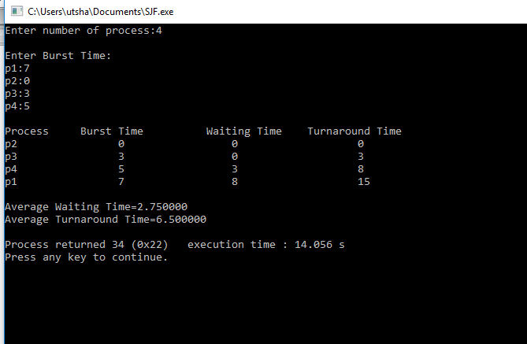

**Conclusion :**

Shortest job first (SJF) or shortest job next, is a scheduling policy that selects the waiting process with the smallest execution time to execute next. SJN is a non-preemptive algorithm.It is an essential Algorithm to find the possible best Solution for the process .